BSC – HGP - Assignment 02

Painting Application UI Design Document

**Author: Sarah Brennan**

**Student Number: 2962279**

# UI Design Choice

## Layout

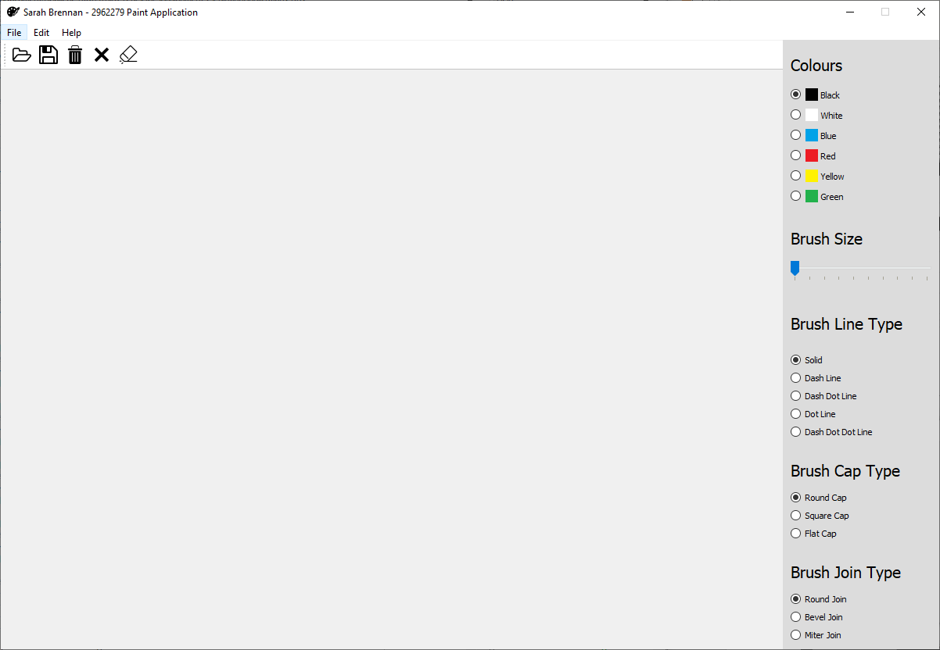

The above is the layout of the paint app.

I created a menu bar at the top, File, Edit and Help. I then created a tool bar beneath with quick links to what is used often in the main menu bar.

I then created a sidebar to be able to be used by user to make changes to the way they are drawing: change colour, change brush size, change brush cap and change brush join.

In File there is the following:

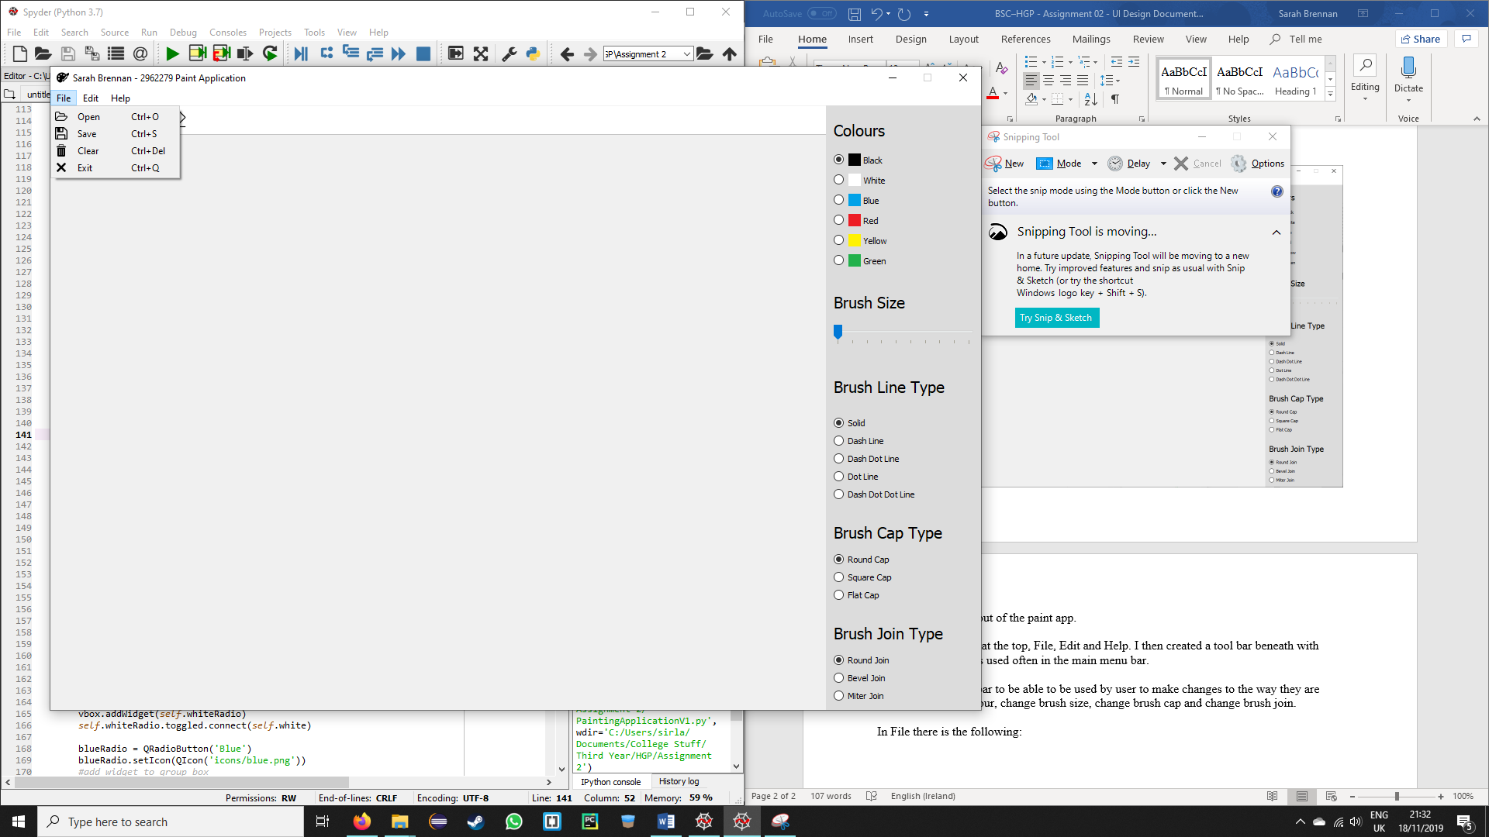

This allows the user to open an existing image, save changes to the image they are making, clear the image being shown and exit the application. There are shortcuts for all of these on the right-hand side

In edit there is eraser which allows the user to delete part of their picture if they want to, there is a shortcut for erase on the right-hand side:

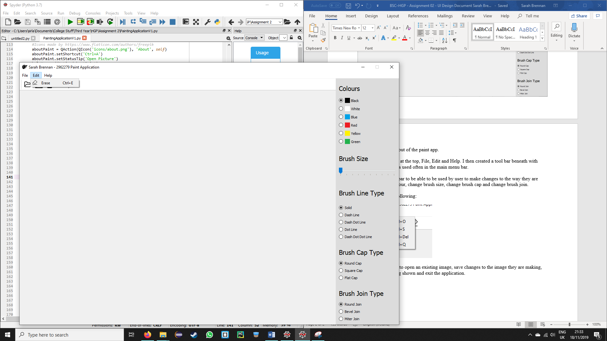

When the erase is selected the cursor changes to a white square with black border.

In help is the following:

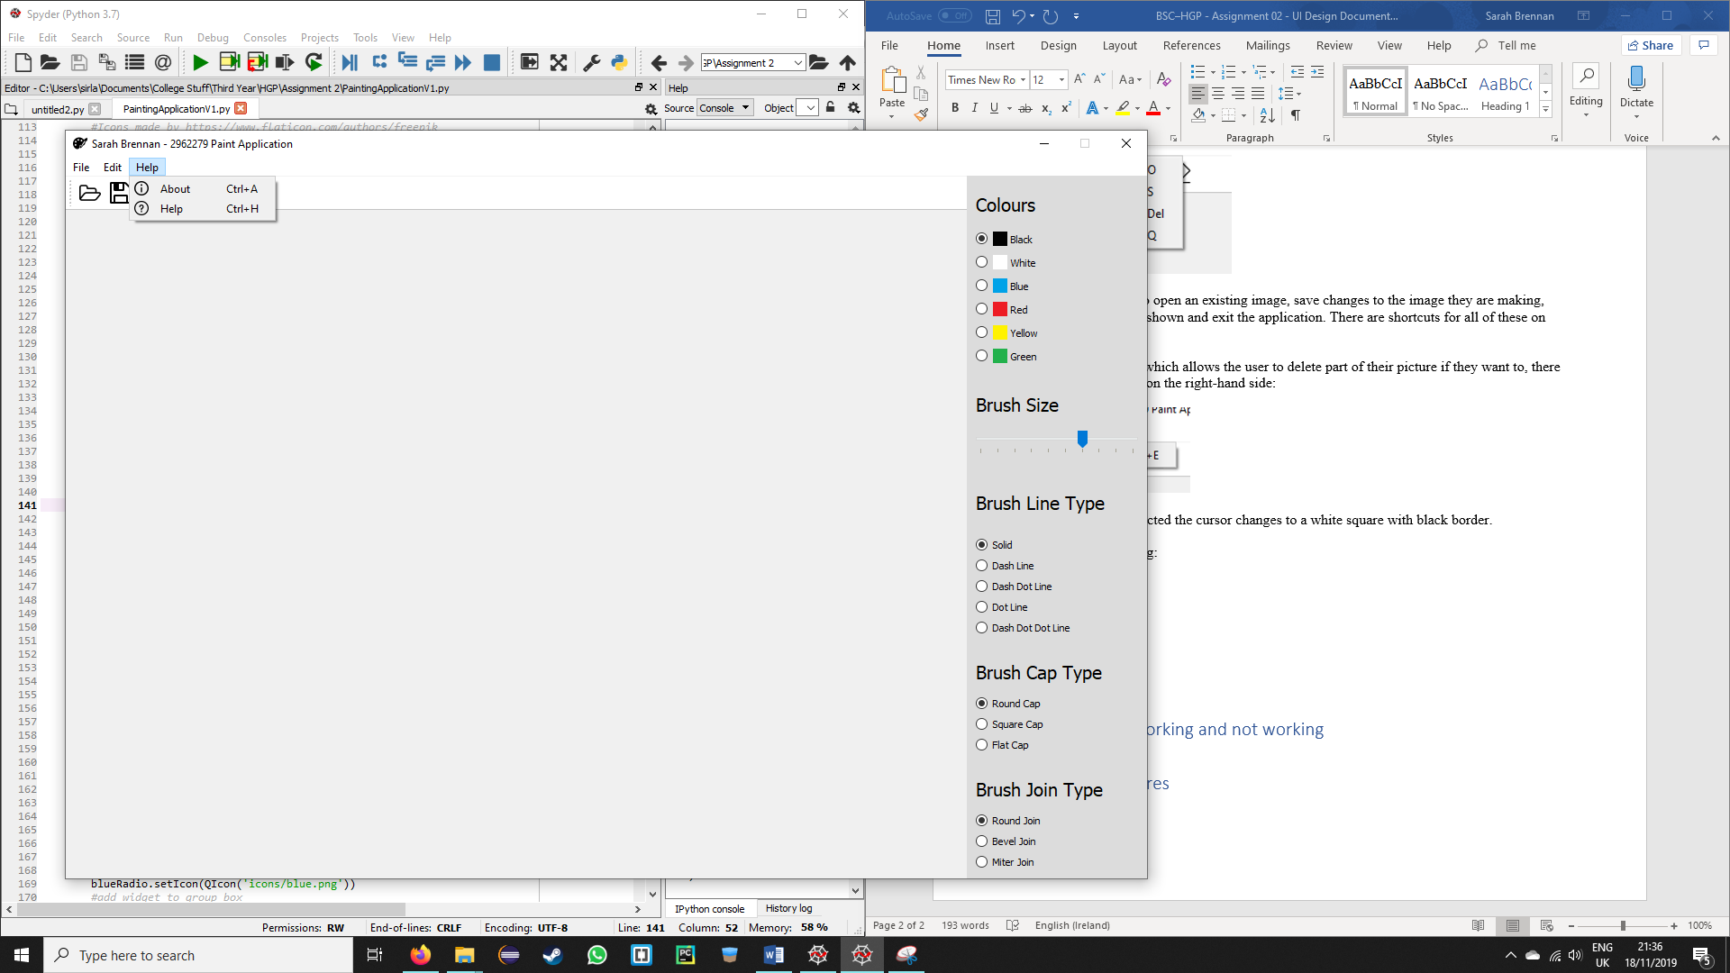

About and Help both bring up message boxes when selected:

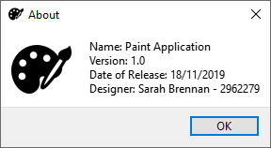

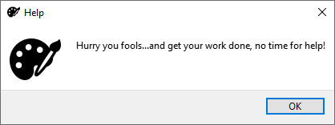

## Widgets Used

For the widgets I mainly used radio buttons, a slider and QGroupBox. Radio buttons were easier for widgets that had a few different options to pick from, I used them in Colours, brush line type, brush cap type and brush join type:

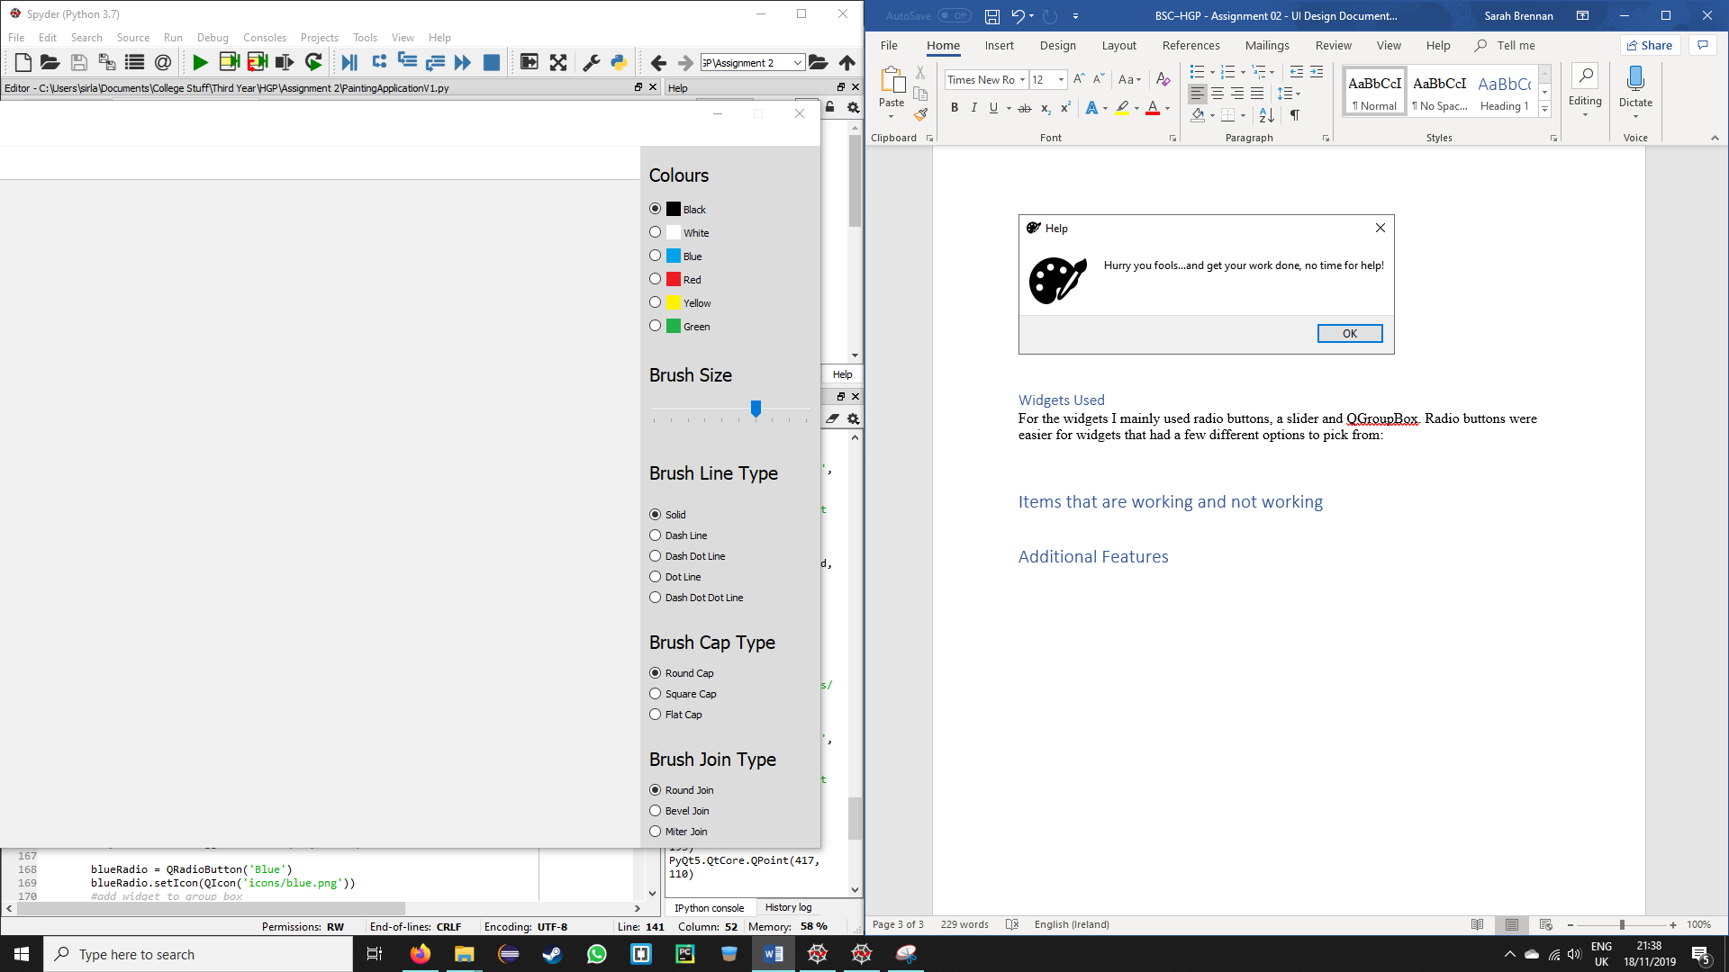



I used the slider in brush size as it was to be a number, which sliders are mainly used for:



Each of these widgets are then contained in their own QGroupBox. This was for ease of adding many items to the same place on the app as it was very easy to do.

# Items that are working and not working

Everything in the application is working, there are just a few things I wished to be able to tidy up but couldn’t.

With the toolbar and the side bar, I had to set the colour as you could see the cursor was apply to draw behind this, I has hoped to be able to set the size of the QImage so it only took up what was needed, but was unable to do so as it didn’t change the size of what was being drawn on.

Also if the user is not fast enough on thicker lines, the line types draw as solid rather then what is selected:

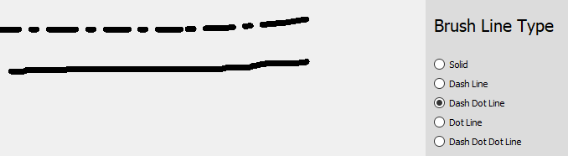

Both lines here were drawn with Dash Dot Line selected, but the one above was drawn quicker then the one below.

# Additional Features

I added a tool bar and icons for additional visual features:

 Tool bar

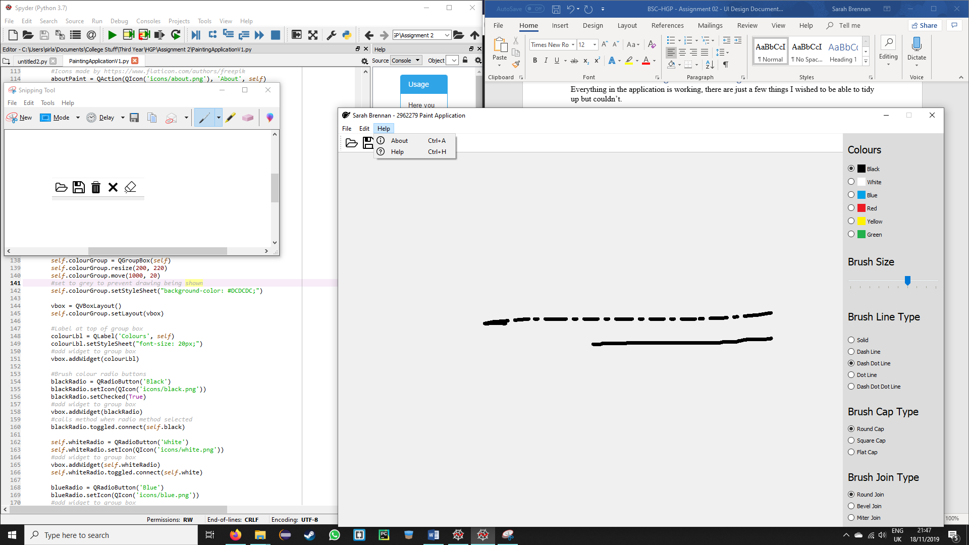 Icons

For addition features I included an erase functionality to make changes to the picture without having to clear the whole thing:

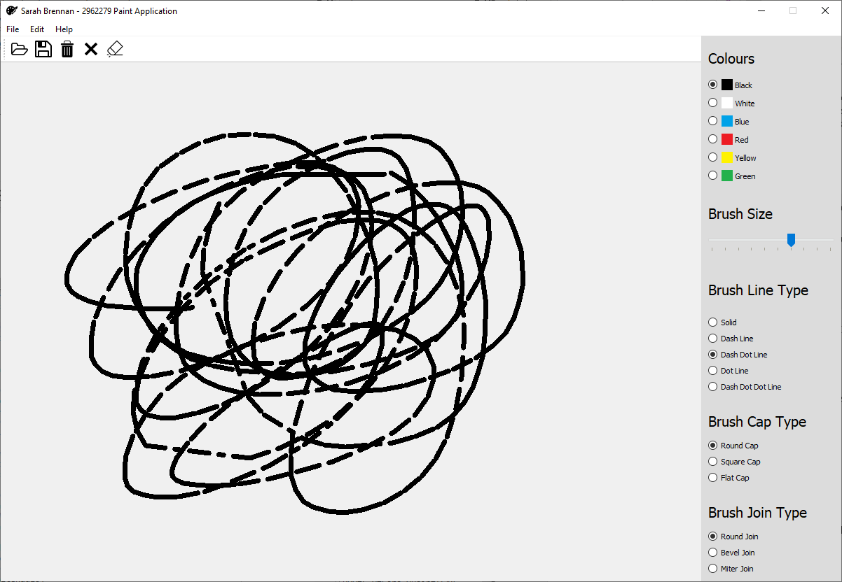 Before being erased

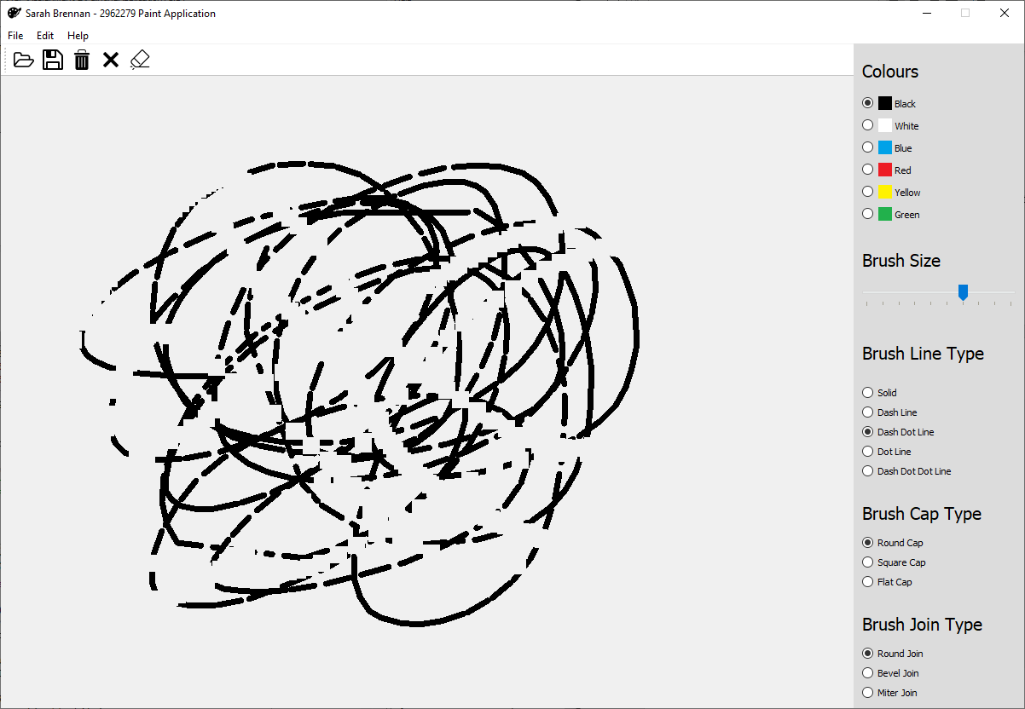 After being erased.

I also added a functionality that if the user wants to exit, they are asked if they want to save their picture first, if they do, they select where to save and then it closes, if they don’t the application closes:

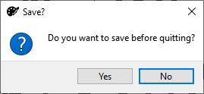

If yes is selected the below appears and once save or cancel is selected the application closes:

